**Instance with port 8080 (home)**

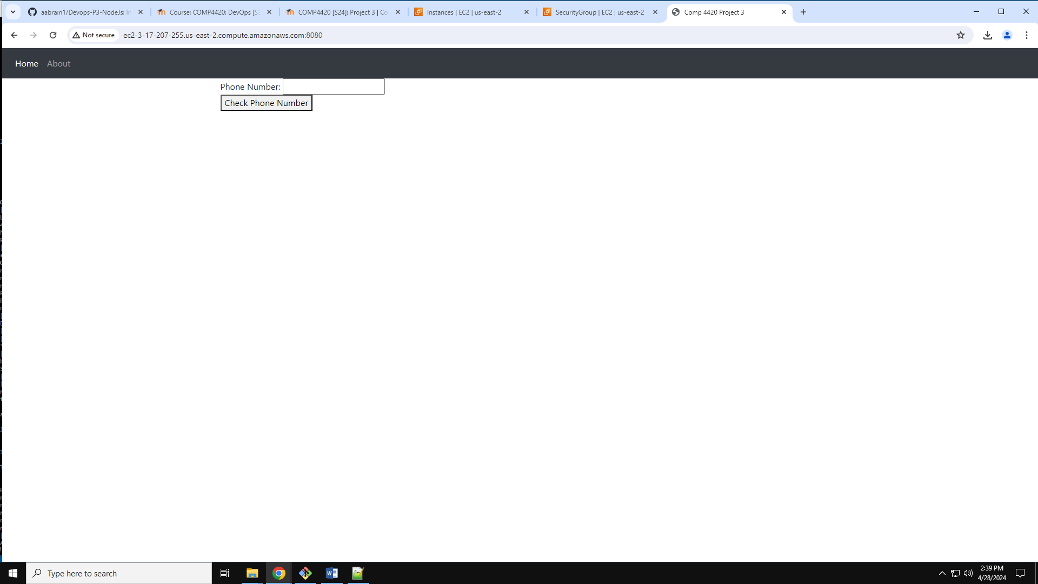

**Instance with port 8080 (About)**

